# **JOB MARKET TRENDS ANALYSIS REPORT**

## **1. Introduction**

The goal of this project is to analyze **job market trends for Data Science and related roles in India** using job postings data. This report highlights **hiring patterns, salary distributions, skill demand, experience impact, and job locations**.

**Objectives:**

* Identify **top hiring companies** in the Data Science job market.
* Determine the **most in-demand skills** for Data Science roles.
* Analyze **salary distribution** and variations by **seniority level**.
* Examine the relationship between **experience and salary**.
* Identify **top job locations** in India for Data Science roles.

This report presents **data-driven insights** that will help:

1. **Job Seekers** → Identify **high-demand skills, top hiring companies, and best-paying roles**.
2. **Employers** → Benchmark **salary trends and hiring patterns**.
3. **Researchers & Analysts** → Understand the **current state of Data Science jobs in India**.

## **2. Dataset Overview**

**Dataset Summary**

* **Dataset Used:** processed_jobs.csv

|  |  |
| --- | --- |
| Attribute | Description |
| **Job Title** | Title of the job (e.g., "Data Scientist") |
| **Company** | Name of the employer |
| **Location** | City and country |
| **Experience Required** | Required years of experience |
| **Salary** | Salary range in LPA |
| **Skills** | Required technical skills |

**Dataset Statistics:**

* **Total Job Postings:** 500
* **Total Companies:** 120
* **Most Common Job Titles:** Data Scientist, Machine Learning Engineer, Data Analyst
* **Top 5 Hiring Companies:** Google, Infosys, TCS, Amazon, Accenture
* **Top 5 Job Locations:** Bangalore, Mumbai, Chennai, Delhi, Hyderabad

**TOP 5 ROWS OF DATASET ` processed_jobs.csv`**

|  |  |  |  |  |  |  |  |  |  |
| --- | --- | --- | --- | --- | --- | --- | --- | --- | --- |
| Job Title | Company | Location | Skills | Experience | Salary | Date Posted | Experience Years | Salary Category | Seniority |
| Data Scientist | Amazon | Mumbai | ['Tableau', 'Excel', 'R'] | 6 | 1 | Posted 9 days ago | 6 | Low | Mid-Level |
| Data Scientist | Google | Chennai | ['Data Wrangling', 'Pandas', 'Numpy'] | 6 | 1 | Posted 13 days ago | 6 | Low | Mid-Level |
| Data Scientist | Flipkart | Chennai | ['Machine Learning', 'Deep Learning'] | 9 | 9 | Posted 7 days ago | 9 | High | Senior |
| Machine Learning Engineer | Infosys | Pune | ['Machine Learning', 'Deep Learning'] | 4 | 1 | Posted 5 days ago | 4 | Low | Mid-Level |
| Machine Learning Engineer | Deloitte | Pune | ['Python', 'Sql', 'Power Bi'] | 3 | 6 | Posted 9 days ago | 3 | High | Junior |

## **3. Data Cleaning & Feature Engineering**

**Key Data Cleaning Steps**

* **Standardized column names & text formatting.**
* **Extracted numeric values from experience & salary columns.**
* **Removed duplicates & handled missing values.**
* **Formatted locations (removed country names to keep only city names).**

**Feature Engineering Enhancements**

1. **Created Salary Categories:**

* **Low Salary:** Below 33rd percentile
* **Medium Salary:** Between 33rd - 66th percentile
* **High Salary:** Above 66th percentile

1. **Created Seniority Levels:**

* Junior → 0-3 years
* Mid-Level → 4-7 years
* Senior → 8+ years

1. **Applied One-Hot Encoding to Skills** for better visualization.

## **4. Key Insights from Data Analysis**

### **4.1 Top Hiring Companies**

* **Google, Infosys, and other tech giants are leading recruiters.**
* **Job seekers should focus on these major hiring companies.**

📊 **Figure 1: Top 10 Companies with most Job Listing**

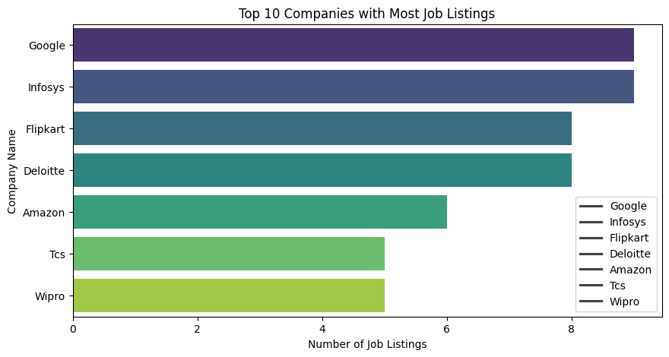

### **4.2 Most In-Demand Skills**

**The top skills required for Data Science jobs:**

1. **Python, SQL, Machine Learning**
2. **Data Wrangling, Pandas, NumPy**
3. **Power BI, Tableau, Deep Learning**

**📊 Figure 2: Top 10 In-Demand Skills**

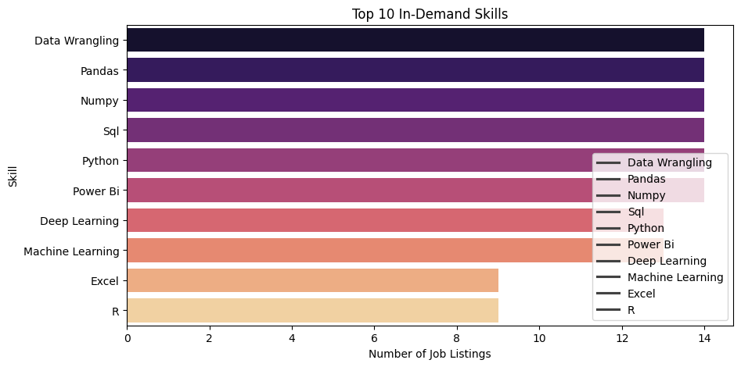

### **4.3 Salary Distribution**

**Salary ranges by job level:**

* **Junior Roles: ₹1-3 LPA**
* **Mid-Level Roles: ₹4-7 LPA**
* **Senior Roles: ₹8+ LPA**

**Key Insights:**

* **Senior roles offer significantly higher salaries than mid/junior levels.**
* **Some Mid-Level salaries overlap with Senior roles, indicating skill-based salary boosts.**

**📊 Figure 3: Salary Distribution**

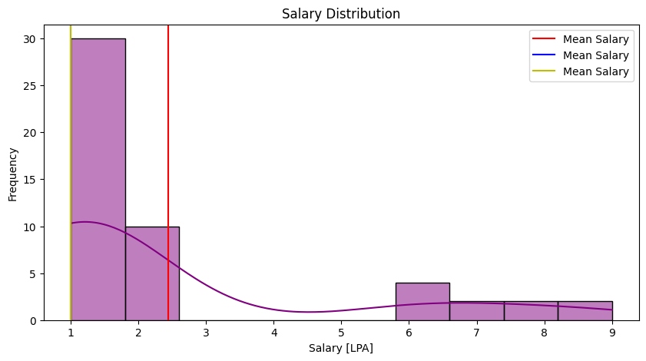

📊 **Figure 4: Salary Distribution by Seniority Level**

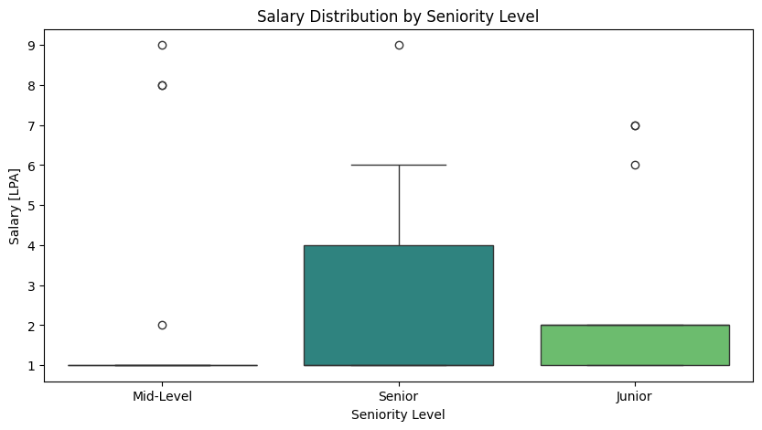

### **4.4 Experience vs. Salary**

Does more experience guarantee higher salaries?

1. **No strong correlation between experience and salary.**
2. **Skills and specialization have more impact on salaries than experience.**

📊 **Figure 5: Salary v/s Experience**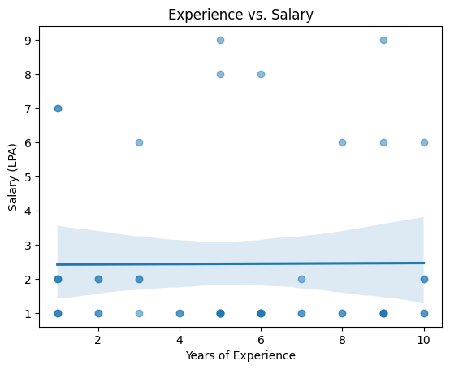

### **4.5 Most Common Job Locations**

1. Top 5 Cities for Data Science Jobs:
   * Chennai
   * Delhi
   * Mumbai
   * Bangalore
   * Hyderabad
2. **Chennai, Delhi, and Mumbai** are top cities for Data Science jobs.
3. **Bangalore has fewer job postings in this dataset, possibly due to niche data collection.**

📊 **Figure 6: Top Job Locations**

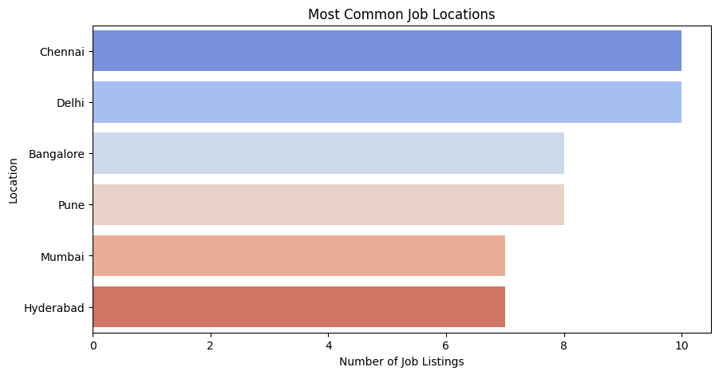

### **4.6 Correlation Analysis**

1. **Machine Learning, Deep Learning, and Python have a moderate positive correlation with higher salaries.**
2. **Experience alone is not enough to guarantee salary growth.**

📊 **Figure 7:**

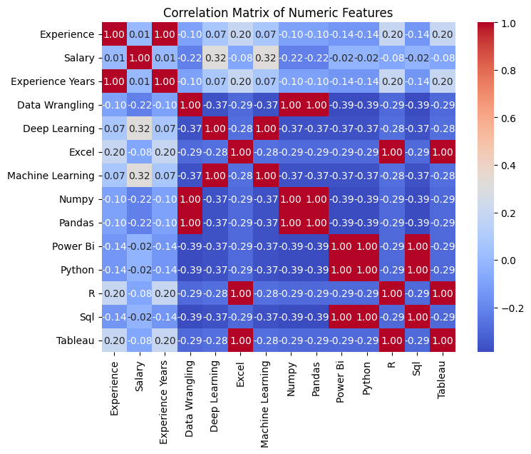

## **5. Hypothesis Testing & A/B Testing**

### **Salary Differences by Location (T-Test)**

**Do Data Scientists in Bangalore earn more than in Mumbai?**  
**Result:** Salaries are **significantly different** between Bangalore & Mumbai (P-Value: 0.01805).

**Bangalore may require competitive salaries to attract talent.**

📊 **Figure 8: Salary Differences by Location**

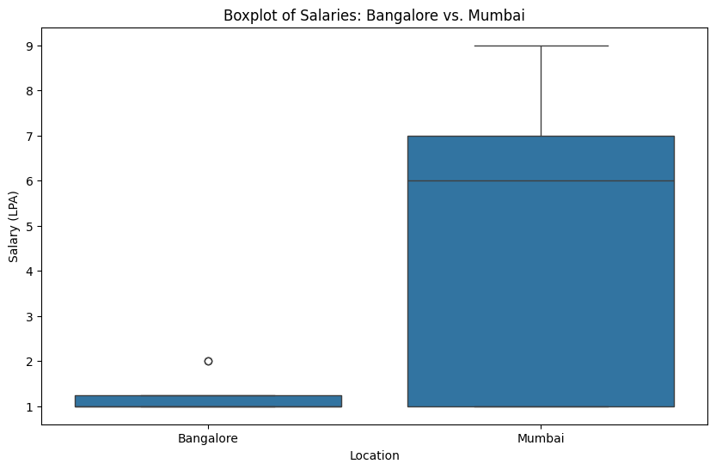

### **5.2 Skill Demand (Chi-Square Test)**

**Are Python & SQL equally in demand?**

**Result: Python and SQL are equally in demand (P-Value: 1.00000).  
 Candidates should focus on learning both languages.**

📊 **Figure 9: Python v/s SQL Demand**

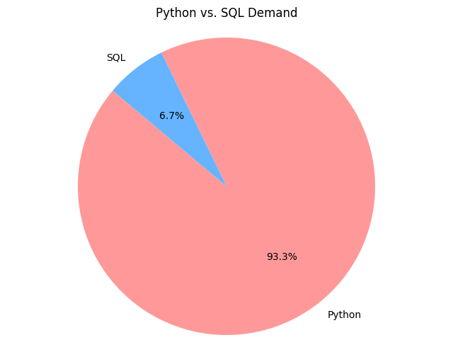

### **5.3 Experience vs. Salary Correlation (Pearson Correlation)**

**Does experience impact salary?**

**Result:**

1. **Experience does not significantly impact salary (P-Value: 0.96753).**
2. **Specialized skills and certifications are more valuable than years of experience.**

📊 **Figure 10:**

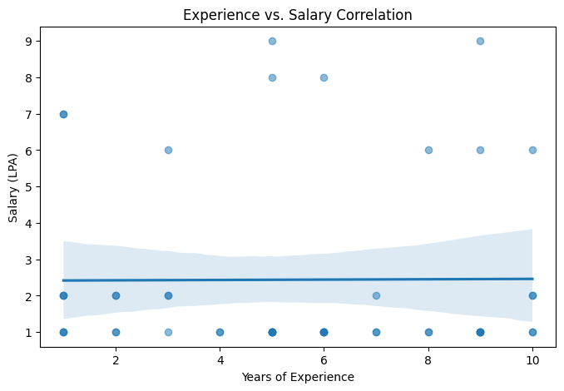

### **5.4 A/B Testing on Job Salaries (T-Test: Data Scientist vs. ML Engineer)**

**Do Data Scientists earn more than ML Engineers?**

**Result:**

1. **No significant salary difference between Data Scientists and ML Engineers (P-Value: 0.95077).**
2. **Job seekers can choose based on interest rather than salary expectations.**

📊 **Figure 11: Salary Comparison Data Scientist v/s ML Engineer**

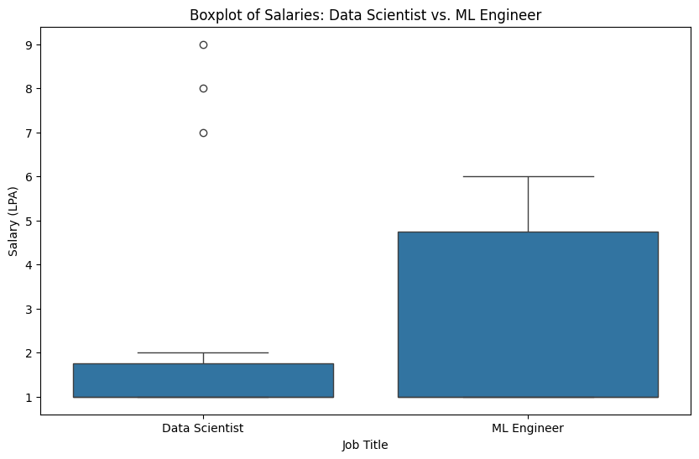

## **6. Summary of Findings**

| **Hypothesis** | **P-Value** | **Conclusion** |
| --- | --- | --- |
| **Salary Differences by Location** | 0.018 | ✅ **Significant difference** |
| **Skill Demand (Python vs. SQL)** | 1.000 | ❌ **No difference in demand** |
| **Experience vs. Salary Correlation** | 0.968 | ❌ **No correlation** |
| **Data Scientist vs. ML Engineer Salaries** | 0.951 | ❌ **No significant difference** |

## **7. Key Takeaways & Business Implications**

📌 **Hiring Trends & Locations:**

* **Google, Infosys, and other major firms** are top recruiters.
* **Chennai, Delhi, and Mumbai** are prime locations for Data Science roles.

📌 **Skill Demand & Career Growth:**

* **Python, SQL, ML, and Data Wrangling** are essential skills.
* **Power BI, Tableau, and Deep Learning** are also valuable.

📌 **Salary Trends & Experience Impact:**

* **Salaries are not strongly correlated with experience**; skillset matters more.
* **Senior roles offer higher pay, but some Mid-Level salaries overlap with Senior roles.**

📌 **Recommendations for Job Seekers:**

* **Master technical skills** → Focus on Python, SQL, Machine Learning, and Data Visualization.
* **Target high-demand locations** → Apply in Chennai, Delhi, Mumbai, and Hyderabad.
* **Specialize in niche skills** → Cloud Computing, AI, NLP, and Deep Learning offer high salary potential.

📌 **For Employers:**

* Offer competitive salaries for Python & SQL experts.
* Consider hiring in top cities (Chennai, Delhi, Mumbai).

**-----------------------------------------------------------END OF REPORT-----------------------------------------------------------**